**LAB 11**

**TASK N0 1**

#include <stdio.h>

#include <string.h>

struct Product

{

int code;

char description[100];

char packaging;

float price;

float discount;

};

float calculateNetPrice(float price, float discount)

{

return price - (price * discount / 100);

}

int main()

{

struct Product products[10] =

{

{101, "Product 1", 'L', 500.0, 10},

{102, "Product 2", 'M', 150.0, 5},

{103, "Product 3", 'L', 800.0, 15},

{104, "Product 4", 'S', 50.0, 0},

{105, "Product 5", 'L', 1200.0, 20},

{106, "Product 6", 'M', 300.0, 7},

{107, "Product 7", 'L', 450.0, 5},

{108, "Product 8", 'S', 100.0, 10},

{109, "Product 9", 'L', 950.0, 12},

{110, "Product 10", 'M', 600.0, 10}

};

for (int i = 0; i < 10; i++)

{

if (products[i].packaging == 'L')

{

float netPrice = calculateNetPrice(products[i].price, products[i].discount);

if (netPrice >= 200 && netPrice <= 1000) {

printf("Product Code: %d\n", products[i].code);

printf("Description: %s\n", products[i].description);

printf("Packaging: %c\n", products[i].packaging);

printf("Original Price: %.2f\n", products[i].price);

printf("Discount: %.2f%%\n", products[i].discount);

printf("Net Price after Discount: %.2f\n", netPrice);

printf("------------------------------------\n");

}

}

}

return 0;

}

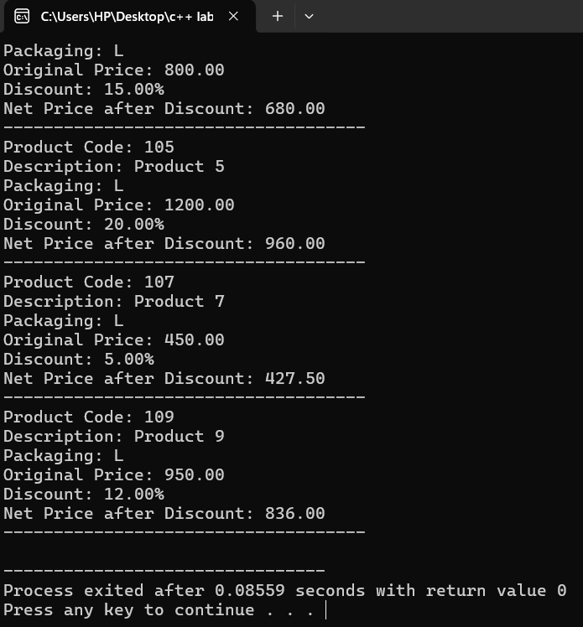

**TASK NO 3**

#include <stdio.h>

void findGreatest()

{

int num, greatest;

printf("Enter 20 values:\n");

scanf("%d", &greatest);

for (int i = 1; i < 20; i++)

{

scanf("%d", &num);

if (num > greatest)

{

greatest = num;

}

}

printf("The greatest value is: %d\n", greatest);

}

int main()

{

findGreatest();

return 0;

}

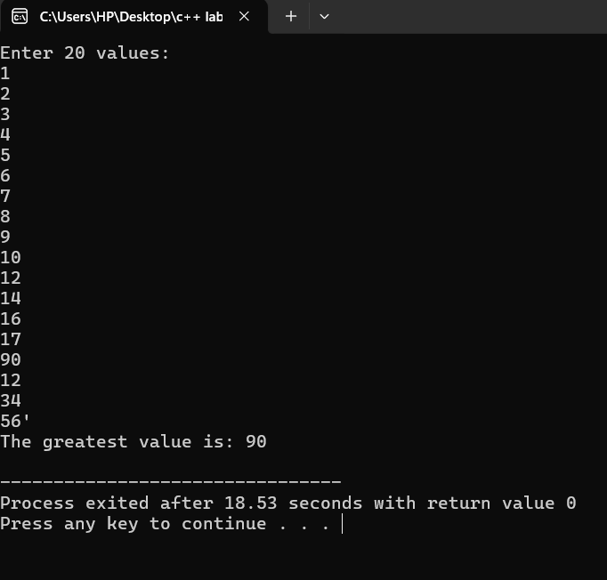

**TASK NO 4**

#include <iostream>

#include <string>

using namespace std;

struct Currency

{

string type;

double amount;

};

double convertToPKR(Currency usdCurrency)

{

const double conversionRate=290.0;

return usdCurrency.amount*conversionRate;

}

int main()

{

Currency usdCurrency;

cout<< "Enter the amount in USD: ";

cin>> usdCurrency.amount;

usdCurrency.type = "USD";

double pkrAmount = convertToPKR(usdCurrency);

cout<<usdCurrency.amount<< " " << usdCurrency.type << " is equal to "

<< pkrAmount << " PKR." << endl;

return 0;

}

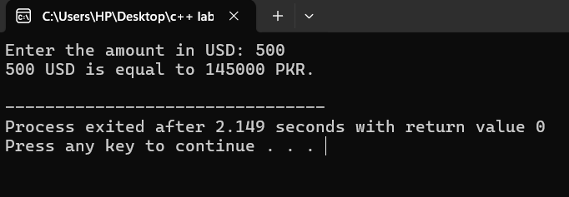

**TASK NO 5**

#include<iostream>

using namespace std;

int budget(int yearly[3][12])

{

for(int i=0;i<3;i++)

{

for(int j=0;j<12;j++)

{

cout<<"Enter the bill";

cin>>yearly[i][j];

}

cout<<"\n*****\n";

}

}

int main()

{

int yearly[3][12];

budget(yearly);

return 0;

}

